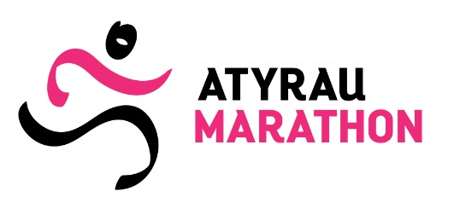
ACKNOWLEDGEMENT NOTE
(to be filled-in with one’s own hand)
I,____________________________________________________________________(full name),
hereby confirm that I am in good physical form, passed necessary medical examination and have no medical contraindications against participation in the races, held within the frameworks of “Atyrau Marathon”.
I am aware of all risks connected with this event and understand that the marathon requires serious athletic training.
I am aware of the fact that as a result of my participation some adverse consequence for my health may arise. I personally bear responsibility for my own health and safety. In case of any accident occurred while or after competitions, upon injury or any physical damage I am acting in my own free will and knowingly refuse from any material and other claims and requirements to the organizers of “Atyrau Marathon”. This waiver of claims also relates to all my successors and trustees.
I have read the Marathon Regulations and schedules and I am aware of the fact that violation thereof may result in disqualification.
I have read and fully understood this document.
I am aware of the fact that I have to receive the participant’s starting at Marathon’s office. I must necessarily have with me:
- Copy of the identity card;
- This Acknowledgement Note, printed out.
I agree that I will not be eligible to compete on February 04, 2024 unless I collect my starter pack.
In accordance with Article 145 of the Civil Code of the Republic of Kazakhstan and for popularization of “Atyrau Marathon”, as well as activities I provide my consent for making my video or photo (photographs and/or video films) by the Fund or any thirds parties, acting for and on behalf of Organizing committee, with respect to my participation in “Atyrau Marathon”, and provide my consent for publication, reproduction and distribution of such images by any methods or any means without restrictions on time or territory of use. I provide this consent on the voluntary basis without any compensation.
«___» ________, 2023 Signature _________________

