The starting number | 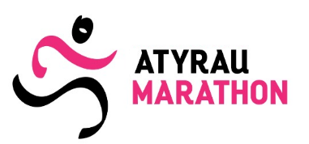
RECEIPT of the participant's health
(filled in with your own hand)
I am, (full Surname First Name Patronymic),

I confirm with this document that I am in good physical shape, I have passed(a) I have a medical examination and have no medical contraindications to participate in the races held within the framework of the Atyrau Marathon VIII.
I am aware of all the risks associated with this event and understand that the race requires serious athletic training.
I am aware that as a result of my participation, there may be adverse consequences for my health. I am responsible for my own safety and health on my own. In case of an accident/death on time or after the competition, injury or physical damage, I voluntarily and knowingly waive any material and other claims and demands against the organizers of the Atyrau Marathon. This disclaimer applies to my possible heirs and guardians.
I am familiar with the regulations and regulations of the race, and I realize that if I violate them, I may be disqualified.
I have read this document and understood its meaning.
I am aware that I need to pick up the participant's starter pack. at the Marathon office.
I agree that I will not be allowed to participate in the competition on October 05, 2025, if I do not pick up my participant's starting package on the days of issue. You must have it with you:
- a copy of the identity card;
- this receipt is in printed form and filled out with your own hand.

In accordance with Article 145 of the Civil Code of the Republic of Kazakhstan and in order to popularize the Atyrau Marathon, as well as popularize mass sports, I hereby give my consent to the Organization. By the Committee or by third parties acting on behalf of and in the interests of the Organization. The Committee, video and photography of my image (photo and/or video clip) / my participation in the Atyrau Marathon, and I also give my consent to the publication, reproduction and distribution, use of my image / name by any means and by any means without limitation in time and territory of use. I provide this consent free of charge.

I confirm that when signing this Receipt, I am not in a state of narcotic, toxic, alcoholic intoxication, for health reasons I can exercise and protect my rights and perform my duties, I do not suffer from diseases that may interfere with the understanding of the essence of the signed document, and I also confirm that I am not under the influence of delusion, deception, violence, threat, a malicious agreement or a combination of difficult circumstances. The Organizer is not responsible for, a Receipt that was not written with his own hand.
The text of this document was read by me independently, the content corresponds to my actual goals and intentions, the meaning of the document and the legal consequences of the document are clear to me.

“ ” _________2025 year. Signature

